**PO1_DGC_Digital Calculator**

**HSI Document**

**Version 1.4**

**Released**

|  |  |  |  |  |
| --- | --- | --- | --- | --- |
|  |  | **Document Change History** | |  |
| **Version** | **Author** | **Date** | **Change** | **Status** |
| 1.0 | Esraa Awad | 23/1/2020 | * Initial creation | Draft |
| 1.1 | Esraa Awad | 30/1/2020 | * Change in Requirement`s names. * Change in system hardware block diagram adding external switch for powering LCD on and off. | Proposed |
|  | Esraa Awad | 7/2/2020 | * Adding a tactile switch in pin configurations and hardware description tables. * Changes in styling format. * Change the document status from “Draft” to “Proposed”. | Proposed |
|  | Nada Mohamed | 8/2/2020 | * Update in Keypad Hardware Description. | Proposed |
|  | Esraa Awad | 3/7/2020 | * Adding requirement name Req_PO1_DGC_HSI_006_V01 for Pins configuration | Released |

Contents

1- Hardware Description 5

2- Pins Configuration (ATmega32 AVR): 7

3- Features description 8

Index of Figures

Figure 1 System hardware block diagram 6

# 1- Hardware Description

|  |  |
| --- | --- |
| Hardware | Description |
| AVR ATmega32 (MCU) | Low-power Microchip 8-bit AVR  RISC-based microcontroller  Program Memory Size 32 (KB)  Pin Count 44 |
| LCD (LMB161A) | LCD Mode: STN Positive Trans reflective  Display Color: Dark Blue  Background Color: Yellow-Green  Driving Duty: 1/16 Duty  Viewing Direction: 6:00  Backlight : LED |
| 4*4 Keypad | Four rows of matrix and four are columns of matrix.  8 pins are driven out from 16 buttons present in the module.  ->Keypad layout :   * First Line [ 1 ,2 , 3 , A ] * Second Line [ 4 , 5 , 6 , B ] * Third Line [ 7 , 8 , 9 , C ] * Fourth Line [ * , 0 , # , D ]   Where ‘A’ represents ‘+’ Plus sign .  ‘B’ represents ‘-’ Subtract sign.  ‘C’ represents ‘*’ Multiply sign.  ‘D’ represents ‘/’ Divide sign.  ‘#’ represents ‘.’ Decimal point.  ‘*’ represents ‘clear’. |
| Buzzer | Resonant: 2300 +/-300HZ  Frequency: 2300 +/- 300 HZ  Rated Voltage: 5V  Voltage range: 4: 8 V  Rated Current: 30 ma  Min Sound output at 10 cm: 85 dB |
| Tactile switch | tactile switch button is released and the pressure has been taking off has 2 pins one for gnd and other for volt. |

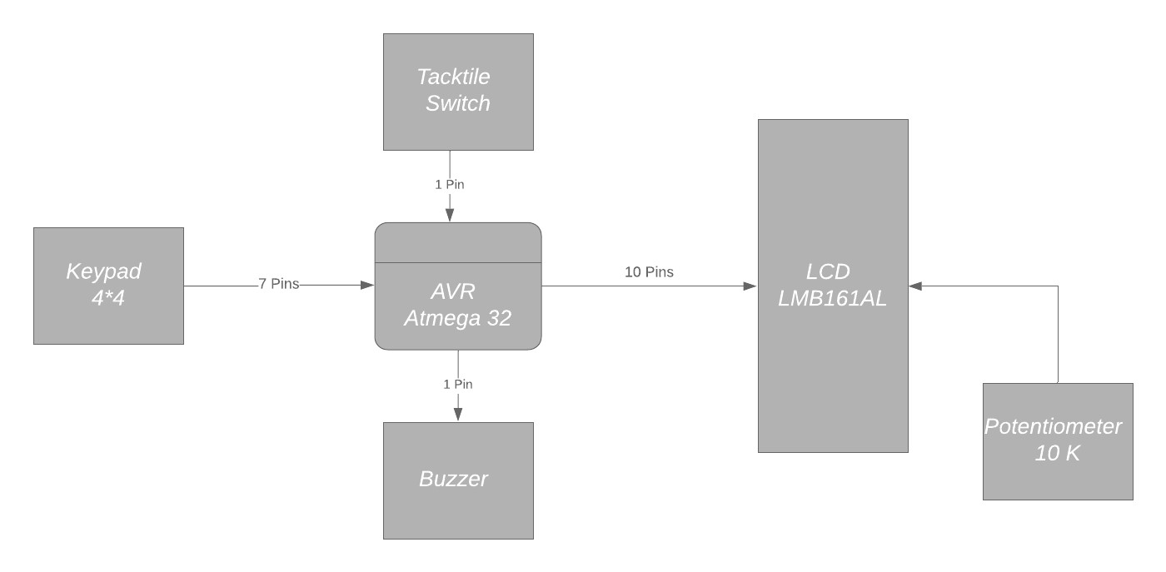

Figure 1 System hardware block diagram

# 2- Pins Configuration (ATmega32 AVR):

|  |  |
| --- | --- |
| Requirement Name  Req_PO1_DGC_HSI_006_V01 | |
| PORT | Configuration |
| PORTA | Pins (0:7 output) connected to data pins of LCD. |
| PORTB | Pins (0:2 output) connected to control pins of LCD. |
| PORTC | Pins (0:7) connected to Keypad pins rows (0:3 Output) and columns (4:7 Inputs). |
| PORTD | (1 Pin output) connected to Buzzer and (1 pin input) connected to tactile switch. |

# 3- Features description

|  |  |
| --- | --- |
| Requirement Name | Hardware Requirement Description |
| Req_PO1_DGC_HSI_001_V01 | Keypad consists of 10 numbers (0:9), basic operation keys (+-/*) and clear key, its eight pins are connected to  MCU. |
| Req_PO1_DGC_HSI_002_V01 | Buzzer has 2 pins one GND and the other connected to MCU as output. |
| Req_PO1_DGC_HSI_003_V01 | Micro controller 8-bit AVR ATmega32 has 32 DIO pins |
| Req_PO1_DGC_HSI_004_V01 | LCD has 3 control pins and 8 pins for data to be displayed on its screen. |
| Req_PO1_DGC_HSI_005_V01 | A tactile switch has 2 pins one GND and the other connected to MCU as input for switching LCD on and off. |